**Ashis Kumar Mahapatra**

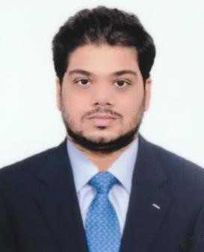

**Correspondence Address- Bhubaneswar,Odisha.**

**Mobile- 9777173245, 9827109223**

**E-Mail- ashismahapatra273@gmail.com**

**CAREER OBJECTIVE:**

To dedicate my technical and professional skills in a dynamic and stable workplace this can facilitate the growth of the organization as well as self.

**ACADEMIC QUALIFICATION:**

|  |  |  |  |  |  |
| --- | --- | --- | --- | --- | --- |
| Qualification | From | To | Institute/Board | CGPA/Percentage | Specialization |
| Graduation (B.Tech) | 17/08/2019 | 05/06/2022 | CIPET (BPUT) | 8.11 CGPA | Plastics  Engineering |
| Diploma | 08/08/2016 | 03/05/2019 | CIPET -CSTS | 66% | Plastics MOULD  Engineering |
| (10+) | 31/03/2013 | 02/02/2014 | BSE, Odisha | 70% |  |
| APDS | 01/05/2017  31/05/2017 | 31/05/2017  01/08/2018 | CIPET -CSTS |  | AutoCAD/Catia  Solid work |

**PROJECT:**

Studies on mechanical & thermal property of recycle polyolefin with fly ash and natural fiber rein forced composite.

**EXPERIENCE**:

**Jay Precision of Pharmaceutical Pvt. Ltd**, Mumbai (Jul-2022 to JAN 2023)

As Production Engineer

* Checking the quality of pharmaceutical devices.
* Setting of parameters for all Injection molding machines.
* Processing of all manufacture documents related to manufacturing of pharmaceutical devices.

## TECHNICAL SOFTWARE:

* Core java
* SQL
* html, CSS

**IT Strength**

* Microsoft word
* Microsoft Excel
* Microsoft Power point

**AREA OF INTEREST:**

* Production
* Quality Control
* Software Developer

**STRENGTH:**

* Discipline
* Confidence
* Hardworking

**PERSONAL VITAE:**

* Date of Birth-31-Oct-1998
* Nationality-Indian
* Marital Status- Single
* Languages Know-English, Hindi, Odia.

**HOBBIES:**

* Listening Music
* Travelling
* Cricket

**DECLARATION:**

I hereby declare that the above information provided by me is true to the best of my knowledge.

**Place Signature**

Bhubaneswar Ashis Kumar Mahapatra